**Applied Machine Learning**

**Lab Report 3**

**Hafiz Ahmad**

**19l-1316**

**Section-8A**

**INTRODUCTION:**

Our goal is to comprehend linear regression within the context of a dataset in this experiment. We can use linear regression to predict the value of one variable from the value of another. The independent variable is the one that is used to make predictions, while the dependent variable is the one that we want to forecast. In order to improve our comprehension, we must observe various datasets and carry out actions like locating the regression of one variable with respect to others.

**OBJECTIVES:**

The objective of this experiment is to gain familiarity with the basic operations of linear regression and observe the changes in the datasets as we perform these operations.

**Procedure:**

We first start this experiment by opening Google Colab. Because we have two datasets, we learned how to import a desktop file into Colab. We download the dataset to the work area, open Colab, and select the document transfer choice in the left sidebar. Following a couple of moments, the document is transferred.

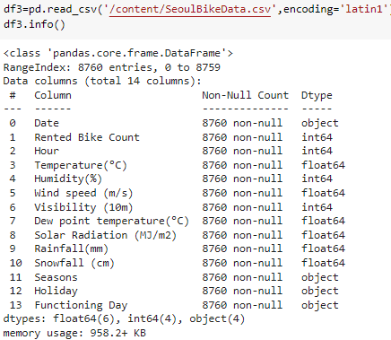

Next, we read the file and select two variables or attributes on which we want to perform linear regression. In this case, we choose the sepal length and the rented bike count and hour using the "df_binary" column. We also change the column name for simplicity.  
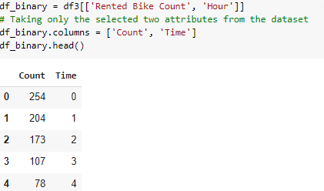

Once we have selected the specific attributes and renamed them, we plot a scatter plot to observe the relationship between count and time.  
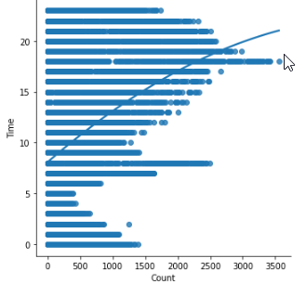

After identifying the relationship, we designate one variable as the independent variable and the other as the dependent variable. In this case, the count is the independent variable, and the hour is the dependent variable. We reshape both attributes to ensure their dimensions are the same. Then, we call the linear regression function and fit it on the independent variable (x) and the dependent variable (y). We calculate the regression between these variables, which is 15%.

We also plot a scatter plot of the predicted values of x and y based on the regression.  
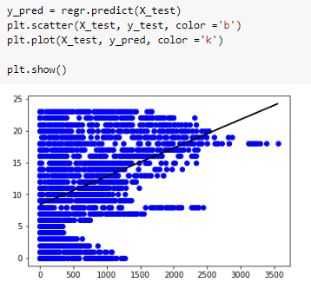

**Application:**

Prediction and classification issues are two examples of the advantages or applications that linear regression provides. For instance, logistic regression models can identify data anomalies that are predictive of fraud and can be utilized for fraud detection.

**Issues:**

No issue found while performing in the lab.

**Conclusion:**

In conclusion, this experiment demonstrated the fundamentals of linear and logistic regression. We were taught how to find the confusion matrix and how to compare attributes accurately. We were able to make predictions and learn more about the relationship between the variables by using the dataset for linear regression.